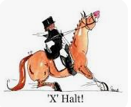

Time | Intro 1 | Time | Prelim 1
17:30 |  | 18:45
17:36 |  | 18:52
17:42 |  | 18:59
17:48 |  | 19:06
17:54 |  | 19:13
18:00 |  | 19:20
18:06 |  | 19:27
18:12 |  | 19:34
18:18 |  | 19:41
18:24 |  | 19:48
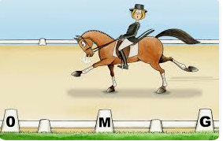

Dressage Rules.
- Children under the age of 16 must be accompanied by an adult at all times.
- Run under British Dressage Rules – find the Rule Book for information via this link – https://bit.ly3xjJrWo
- No ‘wilkie’ type bits – BD legal bits only.
- In the warm up ring: No lunging, no leading, pass left to left, walk on the inside track, no halting on the track please stand in a corner.
- Grooms/spectators must stand behind barriers or in the gallery.
- Please remove boots before your test.
- You will be called 2 minutes before your test.
- Please be respectful.
- Inappropriate language/behaviour will not be tolerated.
- Ribbons: Red: horse kicks, Green: young/inexperienced horse, White: horse for sale.

