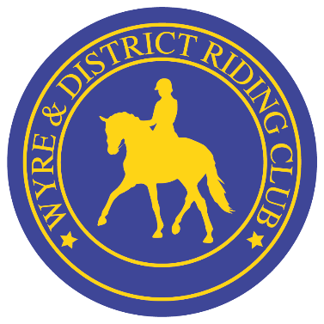

We are preparing ourselves for presentation evening, as we are close to the end of the season. Presentation evening is open to all by ticket purchase via a member. Members efforts are awarded on the evening whether it be 100% attendance, placings within classes (class to be competed in twice in a season) or whether you have been selected for a special award, but most of all to celebrate our success as a club for the year. So if you want a ‘JOLLY GOOD KNEES UP ‘ JOIN US:
As we are delighted to announce this year’s presentation evening will be held at Ribby Hall Leisure Village
Ribby Road
Wrea Green
Blackpool.
PR4 2PR

On Saturday 1stNovember 2025. We have limited availability and tickets are on a first come first served basis. Closing date for tickets will be the 30thSeptember 2025. Arrival will be from 5.30pm to give us chance to eat before the Awards for the season will be presented approximately 7.30pm and then we can celebrate the success of the year with Buster Entertainment. (Timings for this will be confirmed at a later date)

We are also looking for donations of raffle prizes for our raffle table. If anyone would like to contribute a prize, please dm to arrange collection. We will put a poll out shortly so as a club we can decide where we would like the money to go this year.

We are also looking for sponsors for next season for the club, there is lots of different sponsorship packages available and the opportunity to have your advertisement in the printed schedule and on the website. If you would like to receive a copy of this, please ask or if know of a company that would like the details, let us know.

Children’s menu is priced at £12 per child under 8’s
Children’s menu 9-12 years per child at £15
Adult Menu 12 years and over is priced at £26.00 per head.

Hot Buffet style menu is on offer; you can choose what you want a combination of on the evening.

There is no need to complete a menu choice as the meal options available are:
Adults Menu
- Hearty Bowland Beef & Root Vegetable Stew,
- Chicken Tikka Masala,
- Vegetable Hotpot (Ve)
With: Braised Rice
Triple Cooked Chips
Petit Pois
Selection of Homemade Breads
Childrens Menu
- Chicken Goujons, Fries & Beans (if any adult would prefer the goujons these must be requested as a special dietary requirement)
Sweet treats will be on the table for pudding.
Please be aware we require any specific dietary requirements or allergies, please email the club with these requests as we must inform the venue. All menus above are the main allergen group free, but we still need to know if you have any Dietary requirements by law. Many Thanks

As per other events there will be a table plan for the venue for the evening tables are max of 10 and 12’s so anybody wishing to sit with other parties please when booking put these requests in by email and I will try to honour your request.
Full payment will be required to secure your place via Entrymaster.lite. we will advertise when this has been opened.

Please complete with the tickets you require.
ADULT 12 AND OVER £26PP
CHILD 9-12 YEARS £15
CHILD 8 AND UNDER. £12

TOTAL £

Dates for your Diary 2026

- Hairy Pony Show- Sunday March 1st 2026
- 1st Points show – Sunday 26th April 2026
- 2nd Points show- Sunday 31st May 2026
- 3rd Points show – Sunday 28th June 2026
- 4th Points show- Sunday 26th July 2026
- 5th Points show and Annual show 30th August 2026.
- Presentation Evening Saturday 8th November 2026 at Ribby Hall Presto

